Assignment 5

**Introduction**: Assignment No. 5 is on Jena. There are two options to complete this assignment. Option 2 assumes that you have good Java background while Option 1 assumes that you do not have good Java background. This tutorial will cover Option 1, with no java background.

**Assignment Requirement:** There are five required downloads for this assignment, (10 Eclipse Java, (2) Java JDK 1.7, (3) Apache Jena, (4) Pellet, and (5) All Code for Book-Without Jar Files. Follow the instruction to download the required material:

1. **Eclipse Java**:
   1. Search for Eclipse java.
   2. Go to highlighted link.

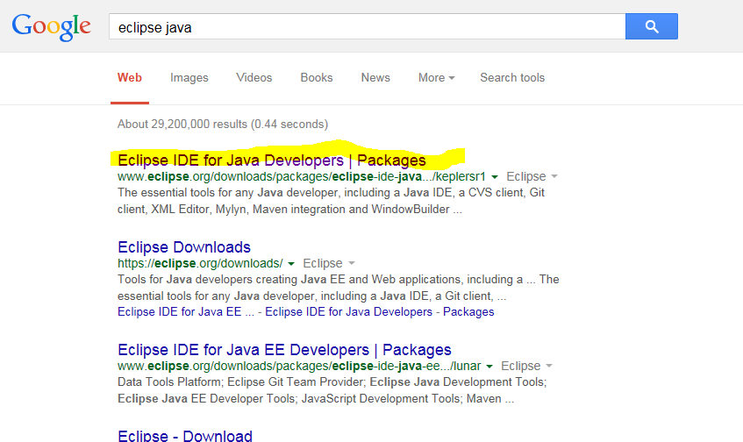

* 1. Download Eclipse according to your OS.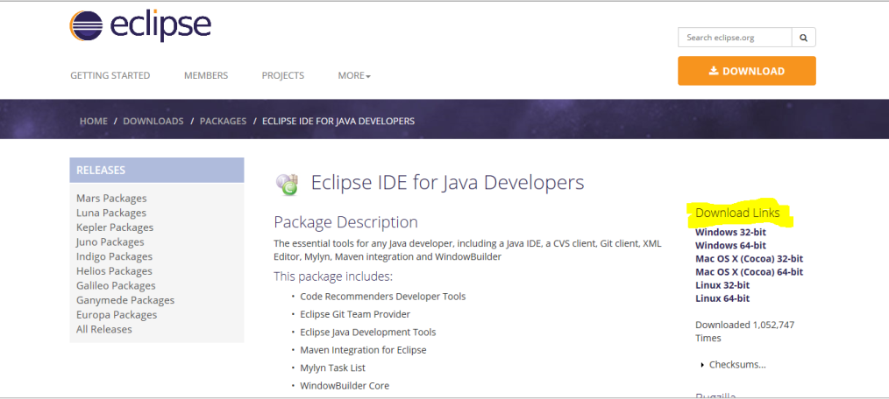

1. **Java JDK 1.7:** 
   1. Search for java JDK 7 download. 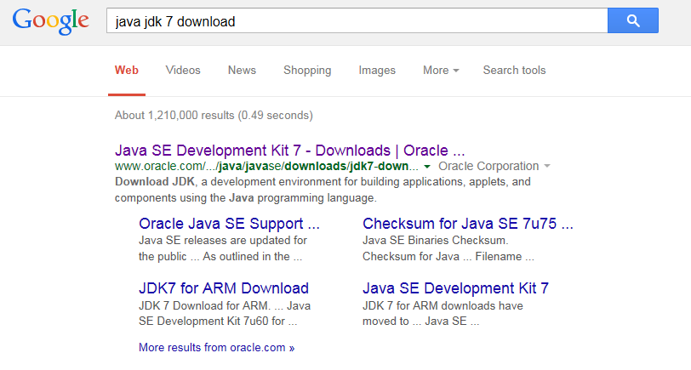
   2. Go to first link.

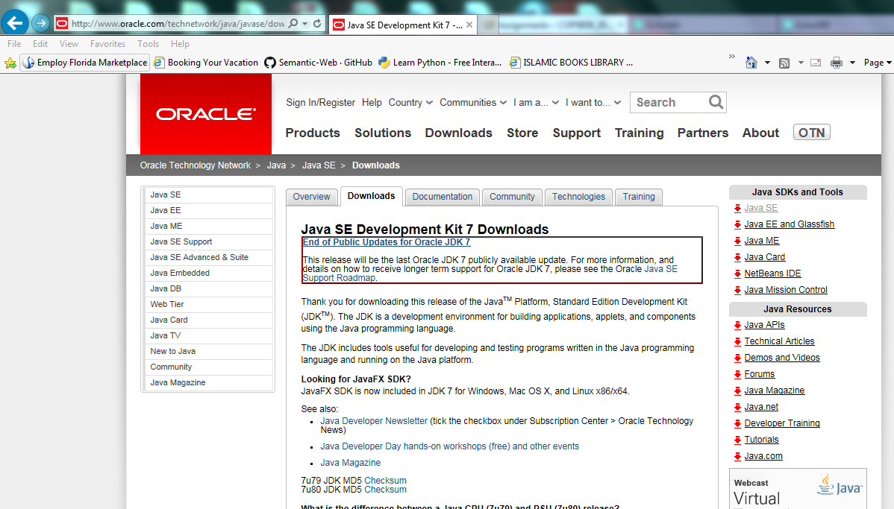

* 1. Download Java JDK according to your OS. 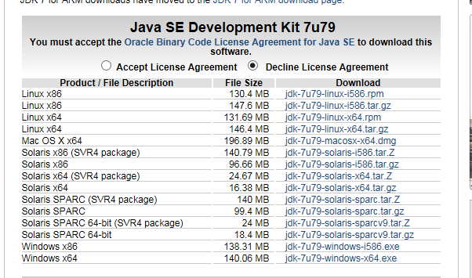

1. **Apache Jena:**
   1. Search for “Jena”. 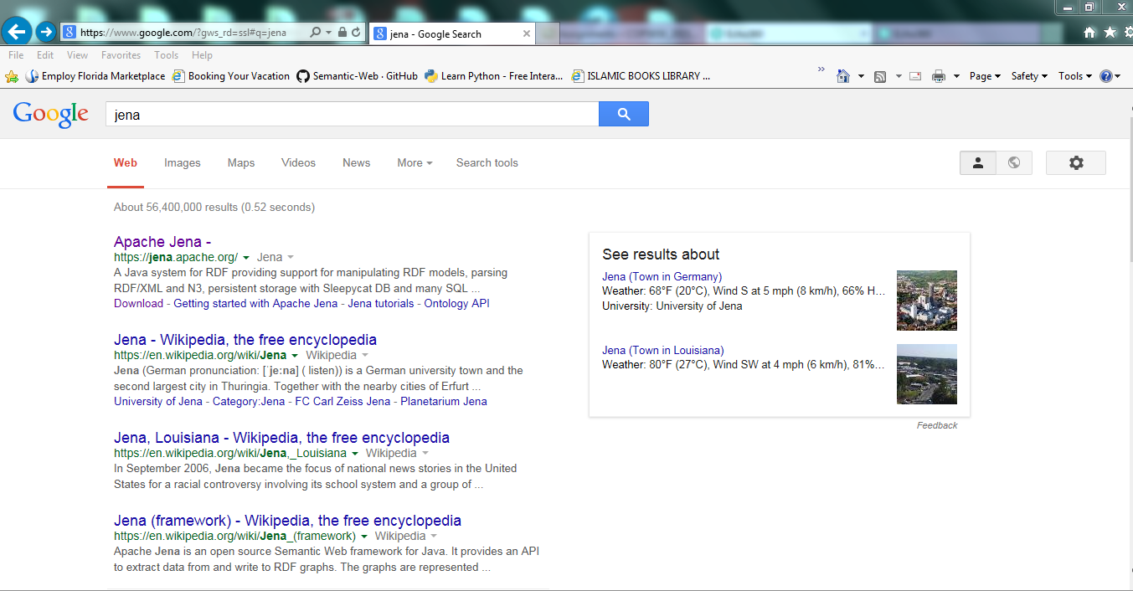
   2. Go to first link “Apache Jena”.
   3. Download Apache Jena. 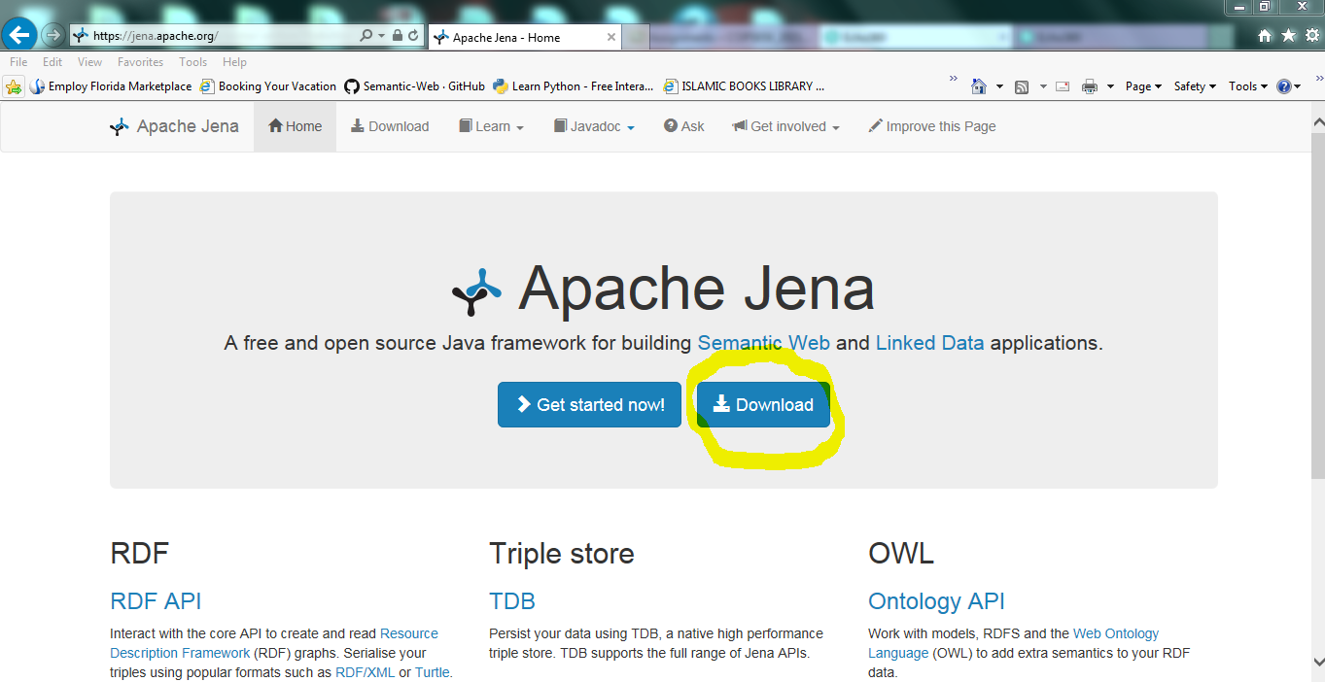
2. **Pellet:**
   1. Go to this link: <https://github.com/ignazio1977/pellet/blob/releases/pellet-distribution-2.3.2-SNAPSHOT-dist.zip>
   2. Click “view the full site”. You will see zip download option. Unzip the content.

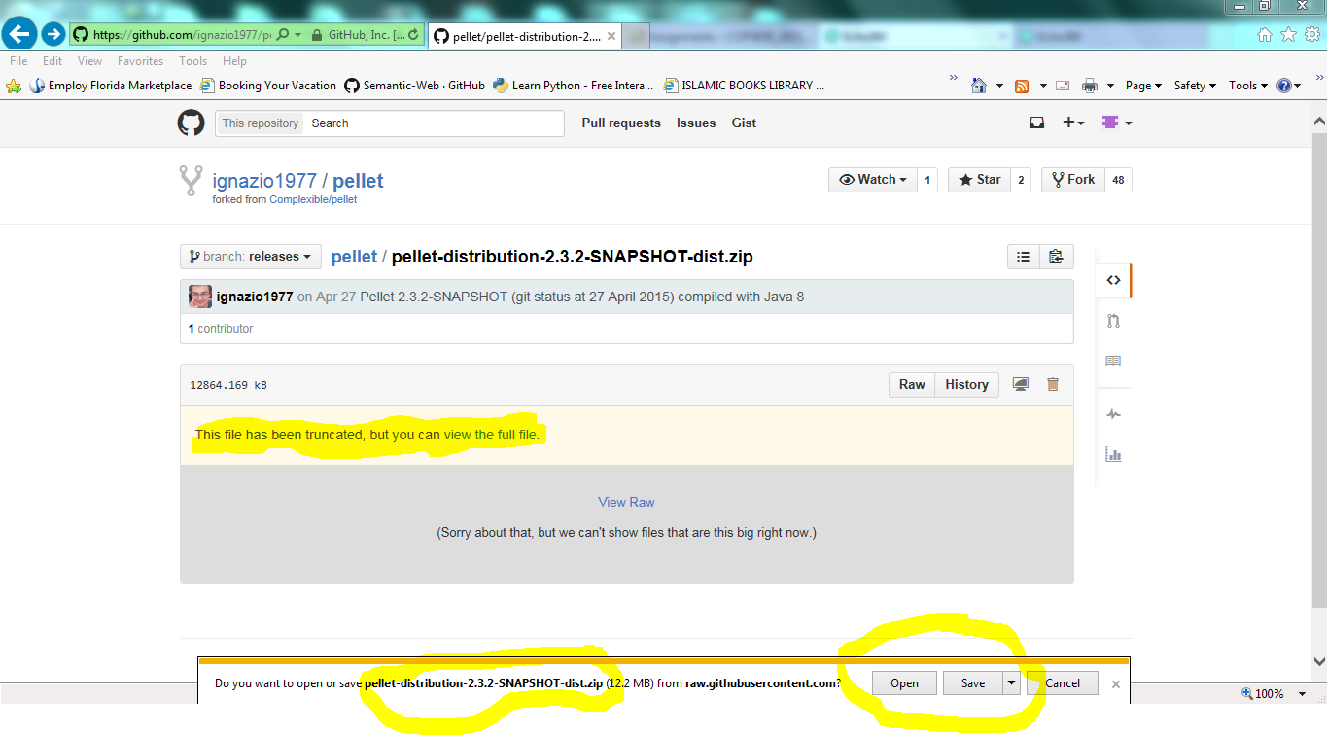

1. **All Code for Book--Without Jar Files:**
   1. Search for “hello semantic web”
   2. Go to highlighted link.

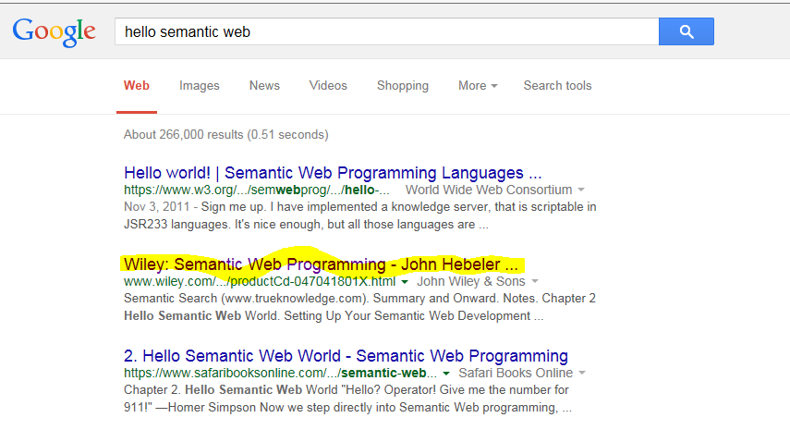

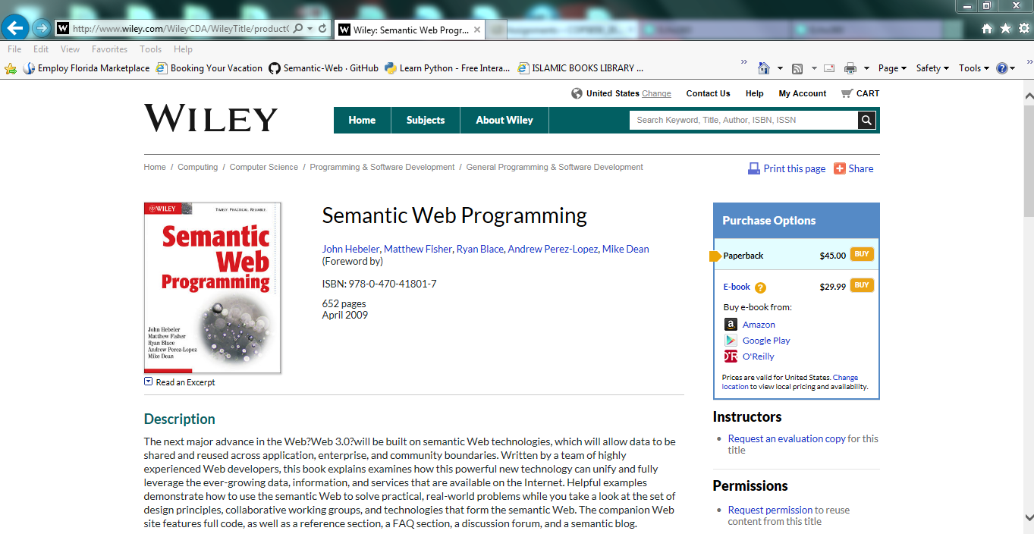

* 1. At bottom of the page you will find highlighted link” All Code for Book--Without Jar Files”. Download and save on your machine. 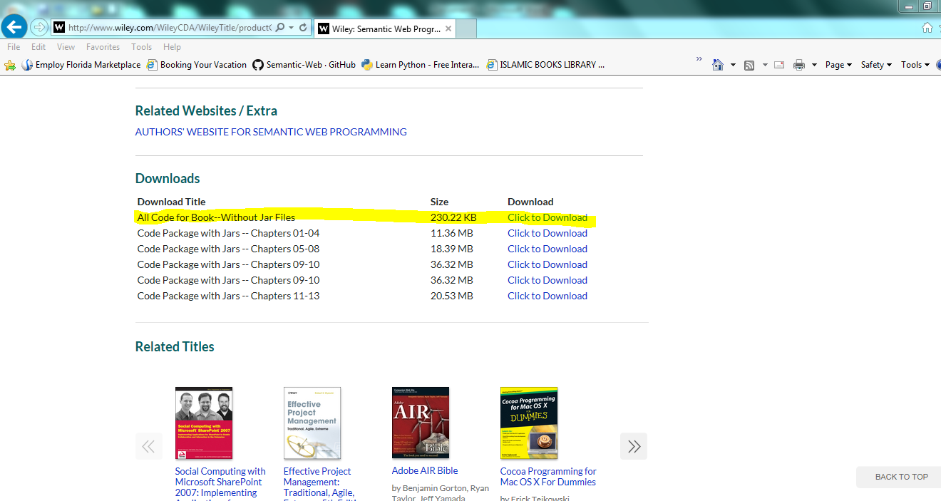
  2. Now you have to make a .rdf file with your name. For this search for “foaf-a-matic”. 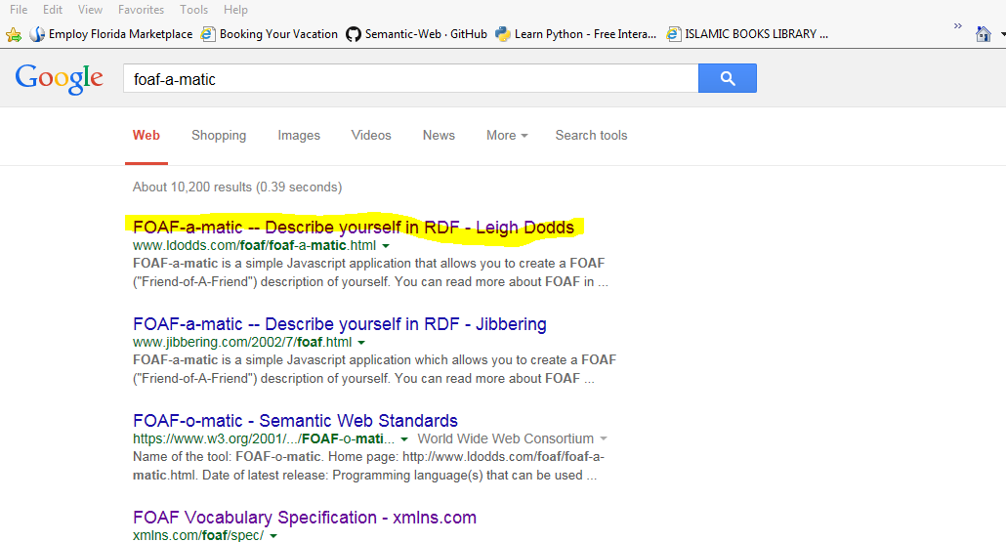
  3. Go to highlighted link and fill up your information to make a .rdf file.

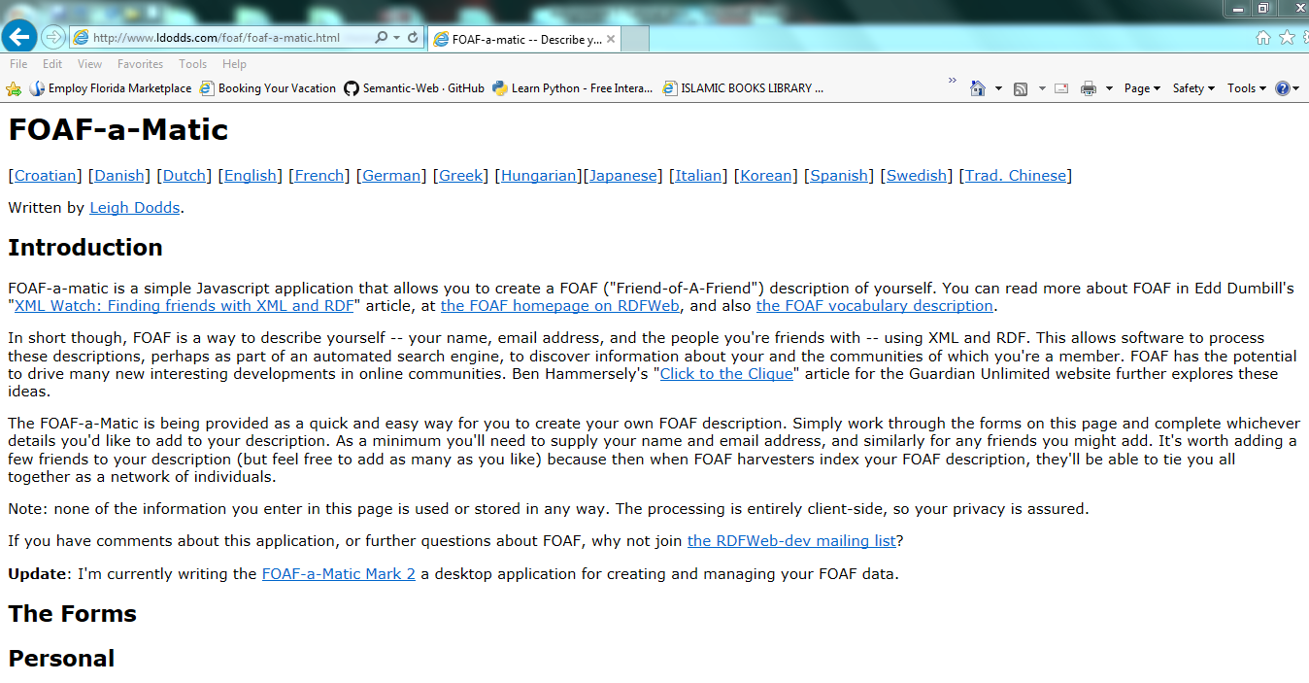

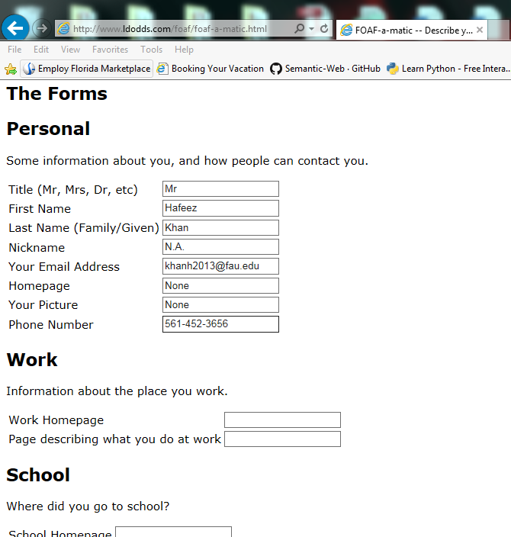

* 1. Click FOAF me and this is your .rdf file. 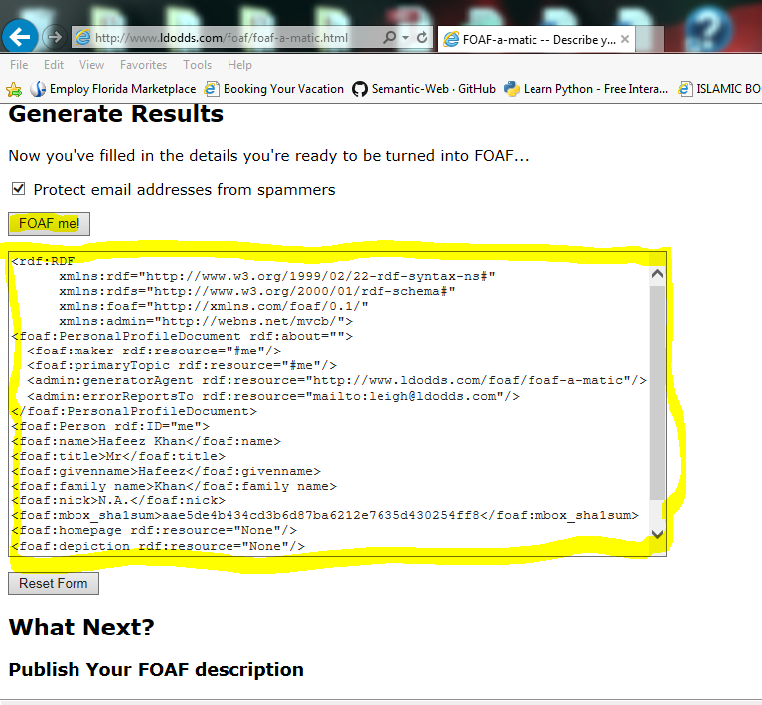
  2. Copy this .rdf file on clipboard and then go to your All_Code_For_Book—Chapter2—HelloSemanticWeb--- Onlologies---- FOAFFriends.rdf. Open FOAFFriends.rdf with notepad and paste your copied .rdf file to FOAFFriends.rfd (Erase content of FOAFFriends.rdf and pastet your code)

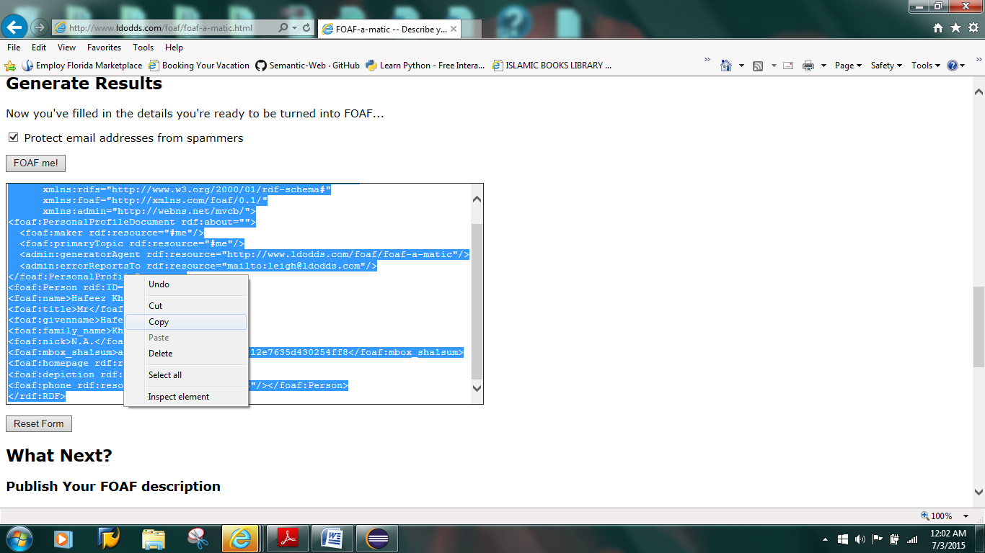

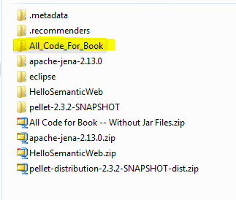

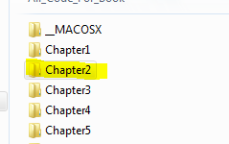

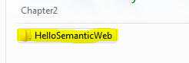

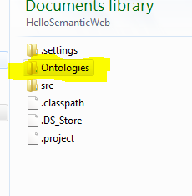

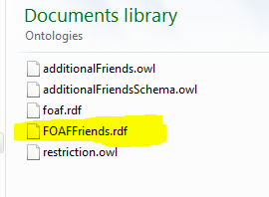

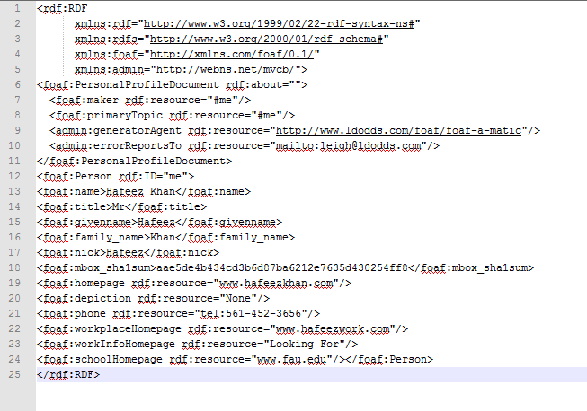

**Starting Eclipse Project:** After downloading all five required contents:

1. Run Eclipse:

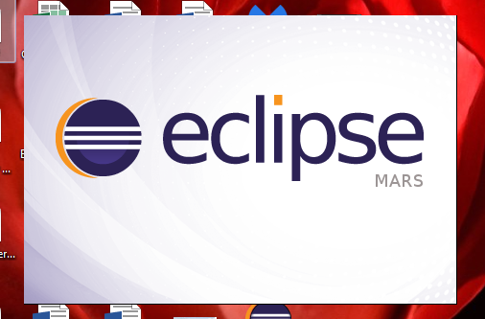

1. Setup Workspace folder: Workspace is the folder where your work/project will be stored. Normally it is setup under C:\\user......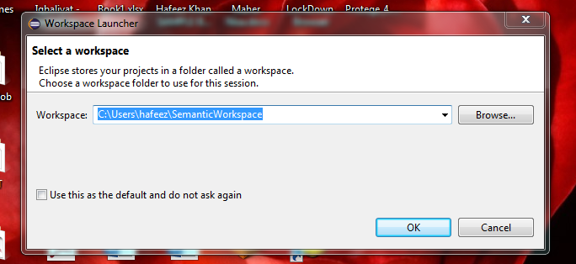
2. Start New Project: Go to File – New – Java Project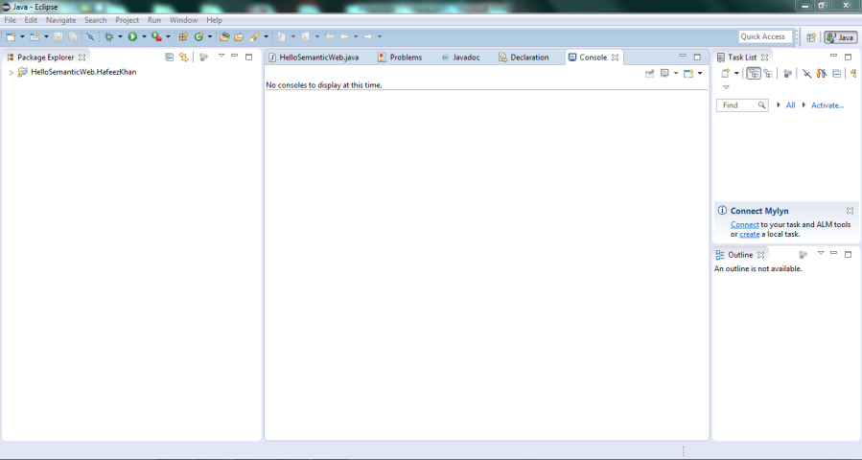

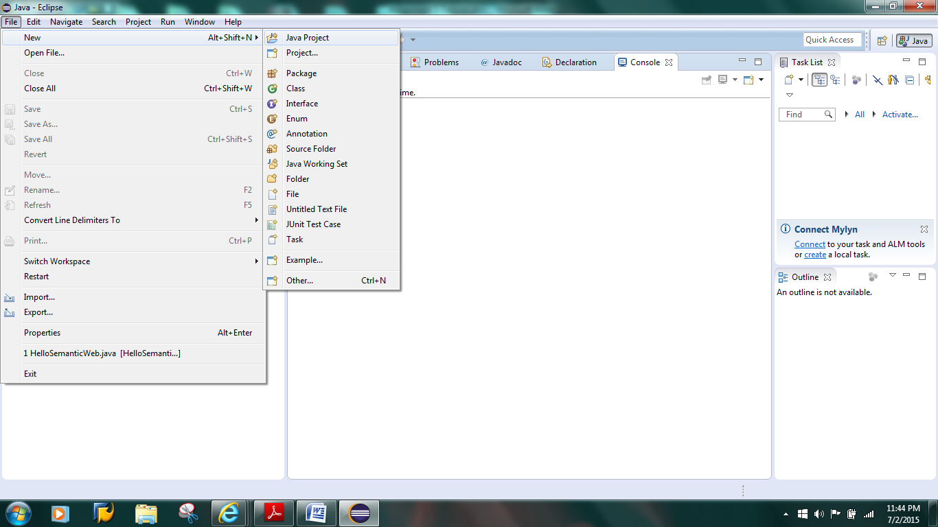

1. Give a name to your project e.g.“HelloSemanticWeb” and click “Finish.

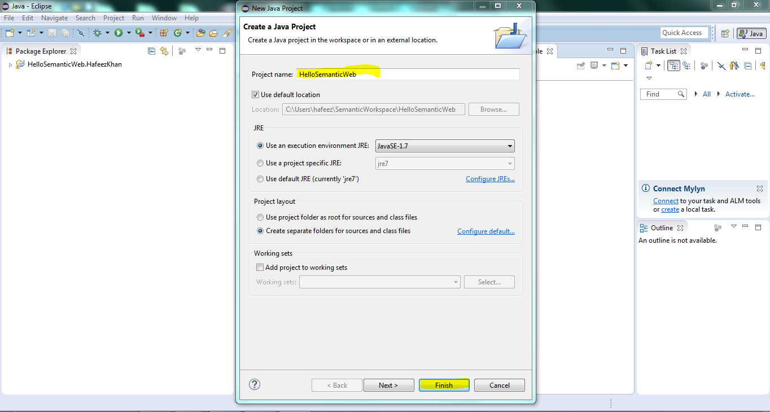

1. You will see your project under ‘package Explorer’ as highlighted.

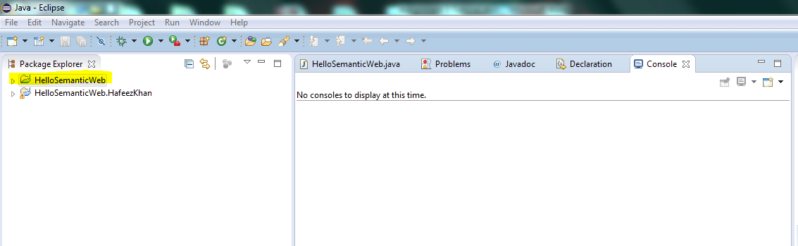

1. You have your project without java source file. Now you have to Import Java file from All Code for Book--Without Jar Files-Chapter 2.
2. Right click on your Project Name and go to “Import”. Go to “General---File System---“.
3. Browse All_Code_for_Book ---Chapter2---HelloSemanticWeb. Import “HelloSemanticWeb” as shown on mentioned screen shots.
4. If you get message about “java path”, ignore the message and press “yes to all”.

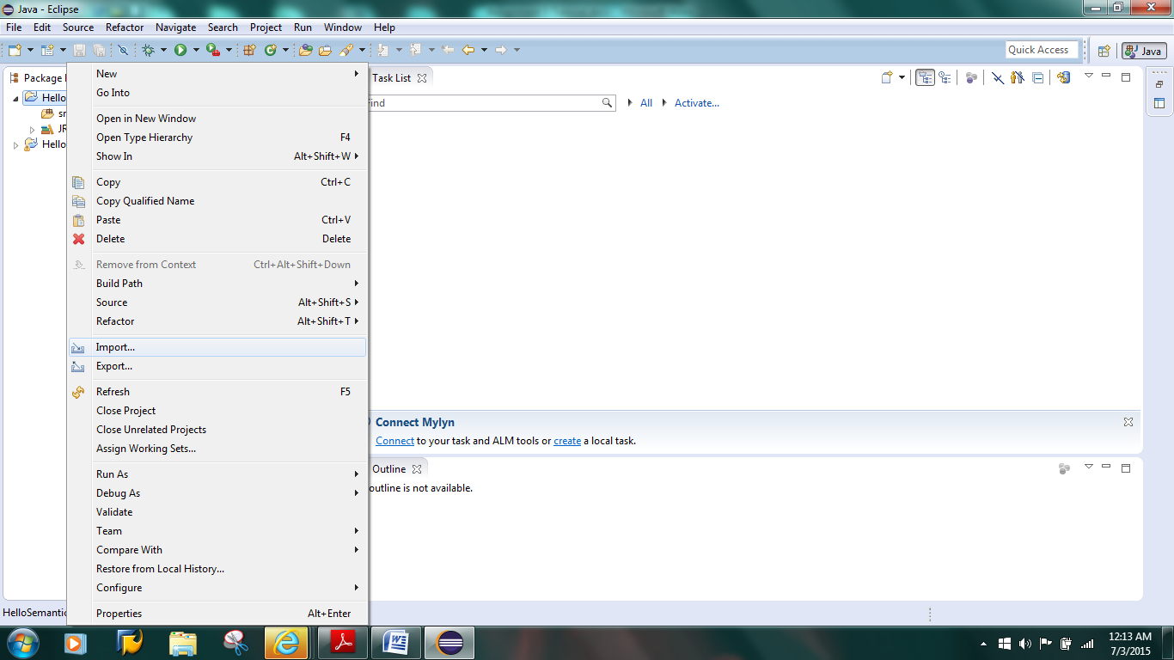

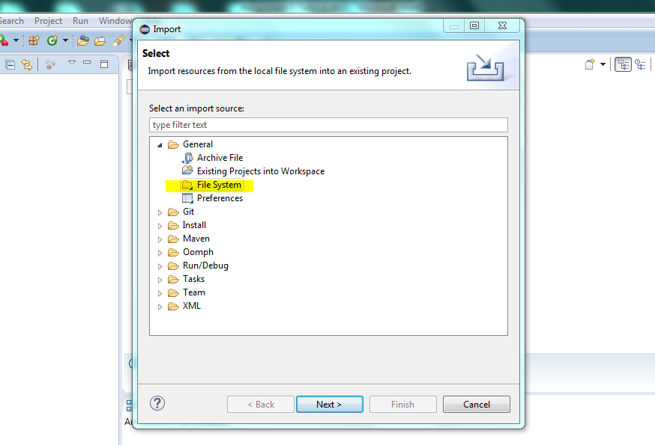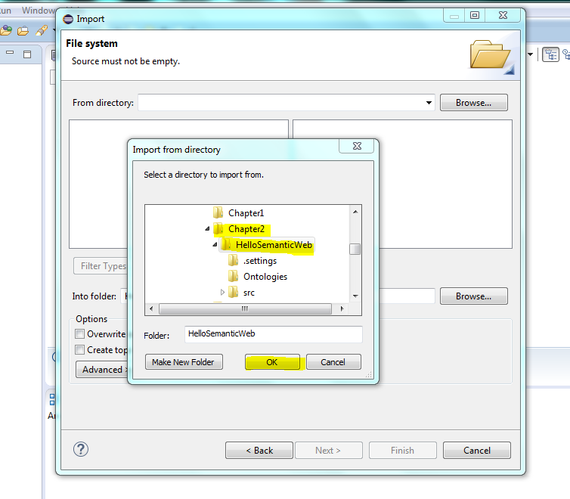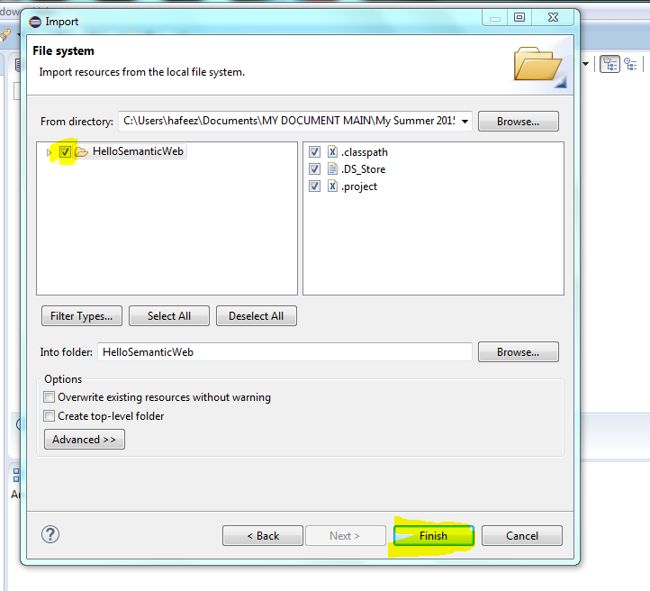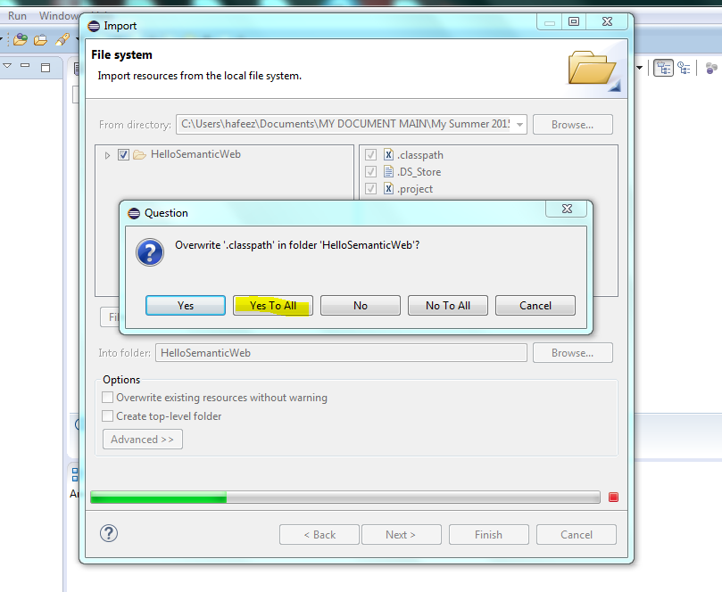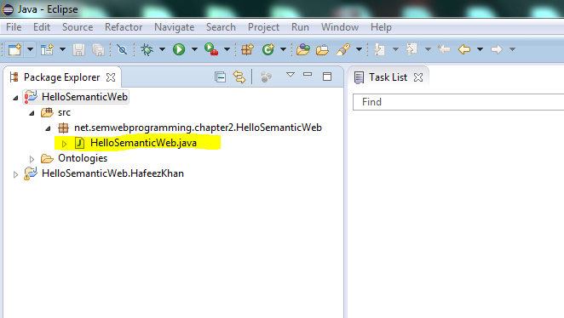

1. Now you have Java source file under your project.
2. Now it is time to Build Path. Right click your project name and go to “Build Path---Configure build Path…”.

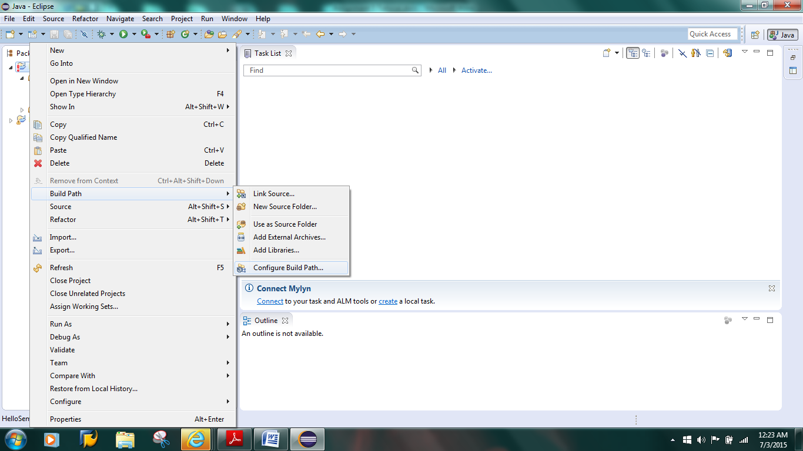

1. Click “Add External Jar....”.

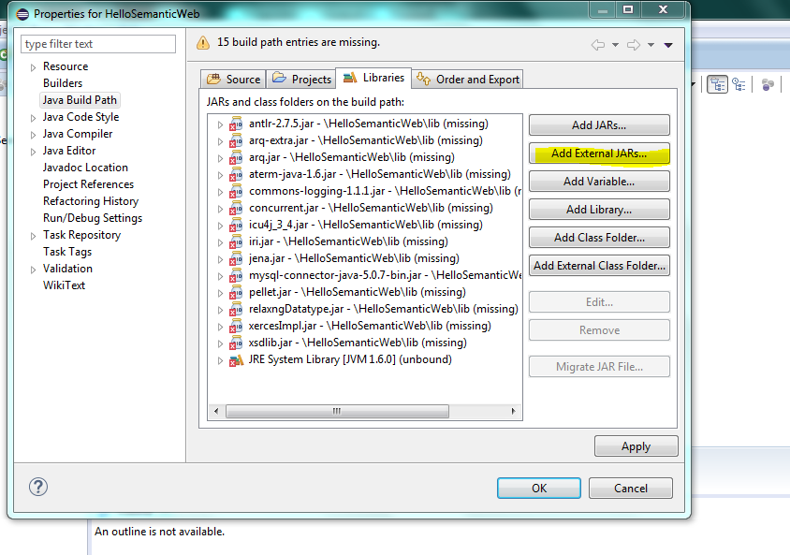

1. Go to ‘Pellet-Lib….” And select all files in “lib” folder starting with pellet ..as shown in screen shot. Click open.

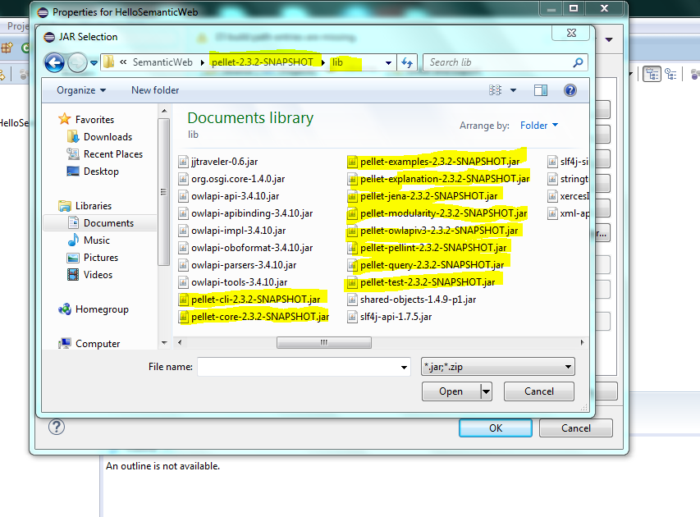

1. Now again click “Add External Jar” and now open all files in “Apache Jena---lib’ folder.

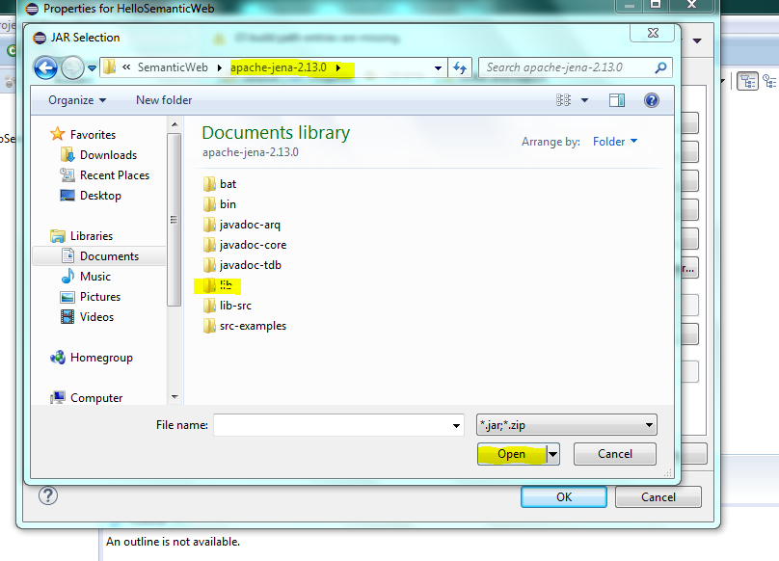

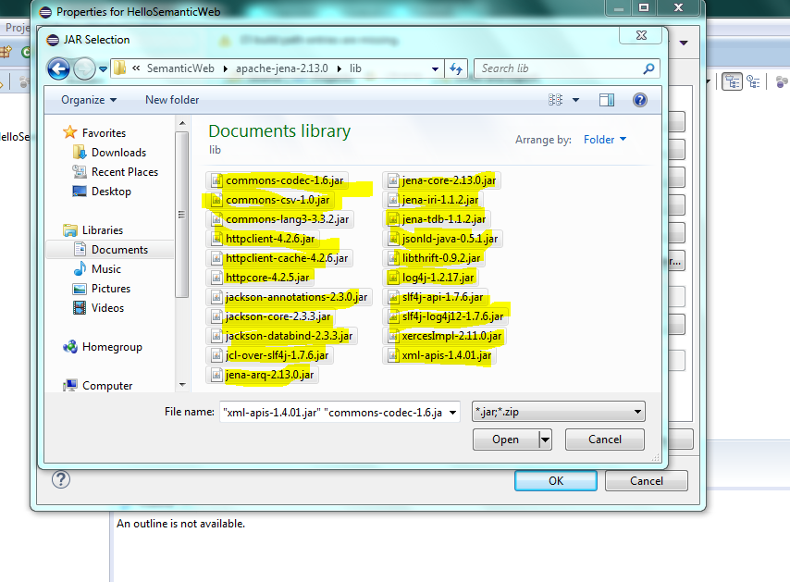

1. Now click ‘Add library”. 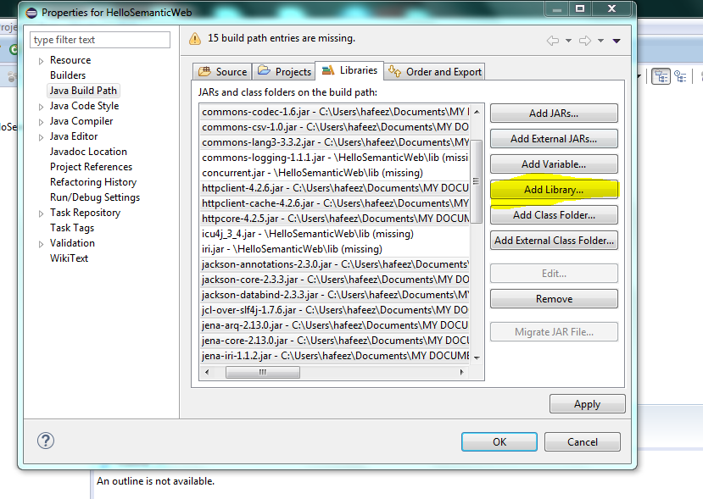

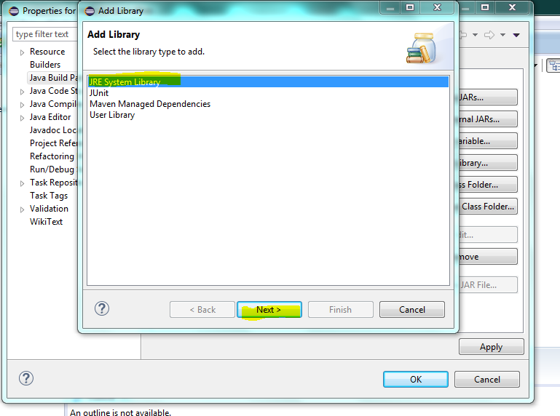

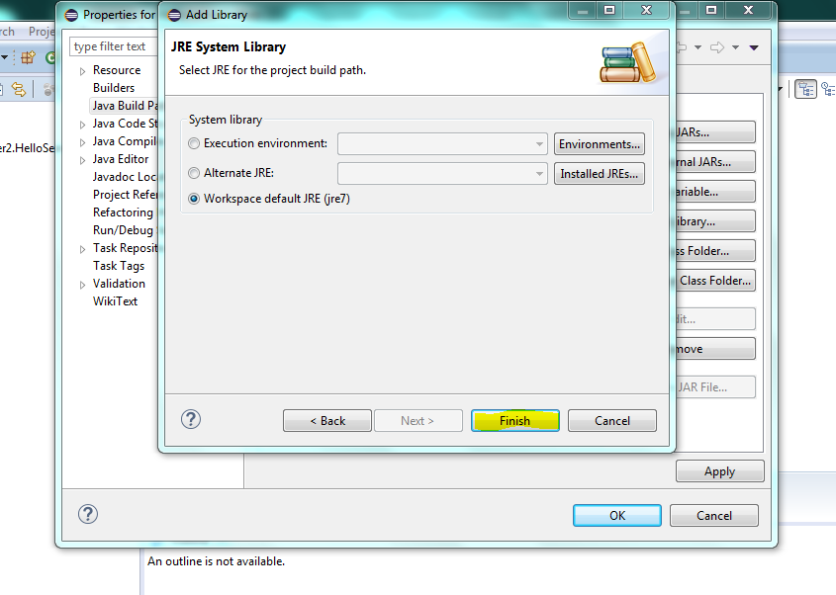

1. Click Finish.
2. Now right click on your project name and run click “Run As-Project Application”. Make sure you don’t have any error on your eclipse.

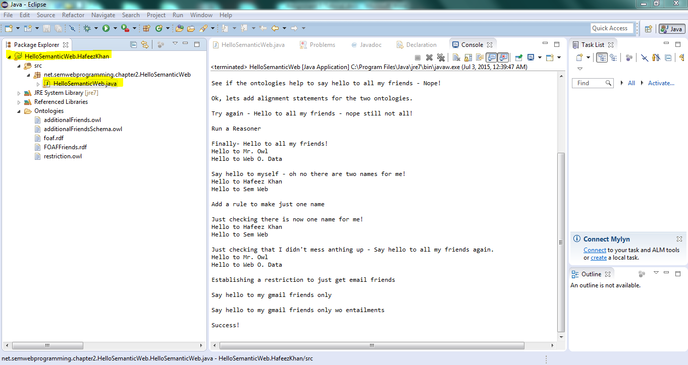

1. You should be able to see the result of your .rdf file in console.